18 Cold Call Objections and Scripts for Each
18 Cold Call Objections and Scripts for Each
I wish the entire cold call was as easy as the first 60 seconds. Your opener and problem proposition are largely static, but you have no idea what will come next.
In a matter of seconds, you need to blunt their knee jerk reaction, mentally process the objection, and say something moderately intelligent to get them talking for 30 more seconds. We’ll break this down down in 2 parts:
How to Handle Objections Like Mr. Miyagi: We’ll break down 3 steps you can use to handle any objection that comes after the first 60 seconds.
- Most Objections Aren’t Really Objections
- Introduction To The Mr. Miyagi Method
18 Common Objections and How to Handle Them: We’ll apply The Mr. Miyagi Method to the 18 most common objections and leave you with talk tracks for each.
Dismissive Objections | - Not Interested  - Call Me In 6 Months  - Send Me Some Information  - Not My Responsibility  - Where’d you get my number!?  - I’m in a meeting!  - Is this a cold call!?  - I thought you were someone else  - *Hang Up*
Situational Objections | - No Budget  - Too Expensive  - No Resources / Bandwidth  - Need to hire someone first  - It’s not made for XYZ
Existing Solution Objections | - We do it in house  - Competitor (Known)  - Competitor (Unknown)  - Stuck in a contract

Warning: Do not just memorize the scripts. Learn the framework and the types of objections first, then use the scripts to see it in action and develop your own style.

Most Objections Aren’t Really Objections
Cold calling might be part of your job, but for your prospect, it’s an entirely unwelcome interruption to their day. The jarring interruption from a stranger sends your prospect into a fight-or-flight state where they’re searching for the first excuse they can find to make you go away.
The first objection is almost always a knee-jerk reaction, not their real objection. They’re not actually considering the pros and cons of anything you’re trying to sell them. They’re just telling you that they don’t like animals so that you go away.
On a cold call, dismissive objections are the same thing: I’m not interested, call me in 6 months, or send me some information aren’t real objections. They’re reactions to the interruption.
This is where most sellers screw up: they try to “handle” those objections by pressuring the prospect with logic. They hurl their pitch at the prospect, reiterate the value of their product, or push for the meeting… but this only makes them push away more.
You can’t overcome emotion with logic: you need to disarm the emotional reaction first. You need to move them from reacting to listening. To do that, you need some sort of pattern break that gets them to realize you’re an actual human capable of having a conversation.
This is the crux of the Mr. Miyagi method. We’re not going to fight objections, we’re going to disarm their reaction by agreeing with them first.

Introduction To The Mr. Miyagi Method
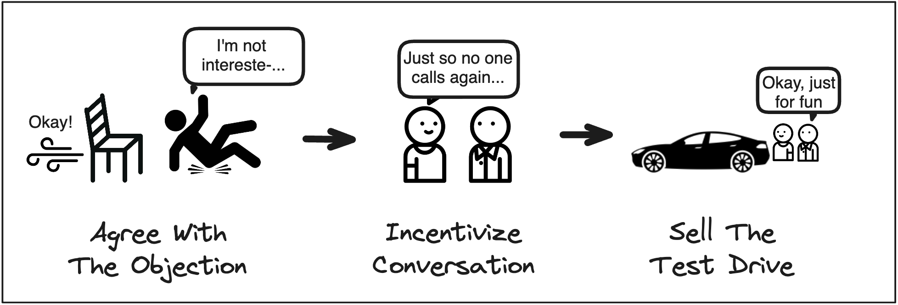
There are three steps to handling any objection in the world like Mr. Miyagi:
Step 1: Agree With The Objection. Objections are often a reaction to the interruption, not your pitch. When you agree with the objection, it feels really dumb to keep fighting someone who isn’t fighting you. That gets them listening instead of reacting.
If someone says “I have no budget,” you could say a line as simple as:
I hear ya. Nowadays, it’s hard enough to keep your budget, let alone add something new.
Step 2: Incentivize Conversation. You still don’t have enough information to handle the objection and they’re still not comfortable enough to hear you out yet. So get them talking and incentivize them to share more by saying… we’re never gonna cold call you again.
Continuing the “no budget” example, it sounds like this:
Just so no one calls you again, is it that you’re out of budget for this fiscal year or you get put through the wringer every time you try to buy something?
Step 3: Sell The Test Drive. So here’s the trick, you still don’t want to sell your product. If you do that, red alert defense mode goes right back up. You want to sell the test drive: why should they take a look at the car, even if they don’t buy it?
For budget, that might be this:
Hey, thanks for opening up here. Look, you’re probably not gonna buy this thing now. But if budget ever frees up, the people that get it at least have a directional sense of what they’d want. Open to taking a look, so you at least know what’s out there?
Ready? Let’s start tackling some objections.

Dismissive Objections
These are the most common knee jerk reactions to a cold call.
The hardest part about dismissive objections is that they’re not real objections. You have nothing to work with because you have idea why they aren’t interested or why you should call back in 6 months. So you have to agree and incentivize them to share the real objection first.
These can also escalate into some of the most abrasive objections of them all. It’s one thing to reason with someone who says I’m not interested. It’s another thing to reason with an irate old man yelling “is this a cold call!?”
Your natural reaction will be to stammer, apologize, and scurry away. Do the opposite.
Dispel the tension with “Disarmingly Blunt” transparency and humor. The more ridiculous their reaction, the more ridiculous your opposite counter-reaction should be:
If someone says… | You say…
Is this a cold call!? | Yes and I’m sorry because it’s going so, so poorly...
I’m in a meeting!! | Oh shoot! Well if you want, you can put me on speaker to publicly apologize to the group and I can really bomb on this one.
Where’d you get my phone number!? | It’s a contact database called Banana Leads. It sounds like I really ruined your day here, so I’d be happy to send you a screenshot of what they have on file so you know what’s out there.

It’s really hard to get mad at someone who’s leaning into the misery of the confrontation or being far more transparent than they could’ve expected by sharing a screenshot of your contact database. Again, it’s like you’re pulling the chair out from underneath them.
Do it right and the prospect should wake up and realize there’s a human on the other line. And at that point, you can ask a question that draws out an actual objection.
Let’s dive in.

1) Dismissive Objection: Not Interested
Not interested is the most common objection in the world. It’s also the most fake objection in the world. They’re not actually contemplating your product, they’re just annoyed and trying to give you as little information as they can to justify a brisk hang-up.
Be disarmingly blunt and agree with this one really hard to wake them up. Blame it on your pitch and call out the fact that they hate getting cold calls so they loosen up a bit. From there, use that to get them to actually think about why they’re not interested:
Prospect: I’m not interested.  You (Agree): Shoot, my bad Nick. I guess either my pitch was really crummy or you would’ve reached out to us if you were interested.  You (Incentivize): Just so I no one calls you again, could you be brutally honest with me…  Is it that you’ve got a solution, you’re not thinking about this problem at all, or you just hate getting cold calls? And it’s okay if it’s #3!  Prospect: We’re already working with Sales Goon.  *From here, run Miyagi again (see objection #16: competitor)* | Guilt to prevent a quick hang-up  Disarmingly blunt  The real objection!
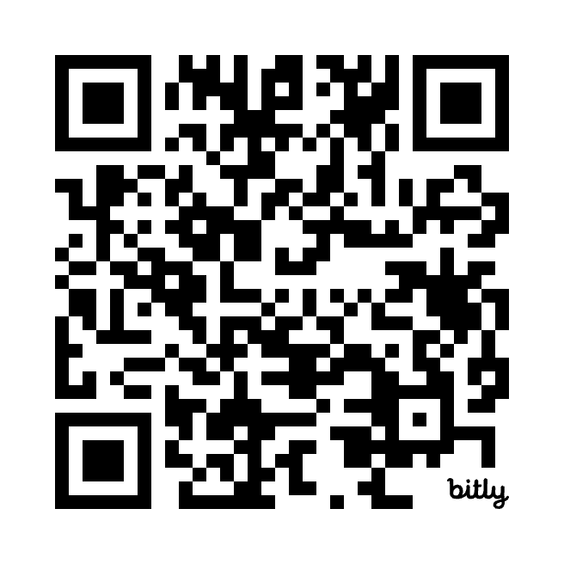

You’ll notice we didn’t sell the test drive because we didn’t have the real objection.
Once you get the real objection (in this case, a competitor), run the full Miyagi Method from the top again and finish it off with the test drive.

2) Dismissive Objection: Call Me In 6 Months
Sure, that meeting’s definitely coming your way in 6 months. Then 9 months. Then 12 months. Next thing you know, your prospect is in the witness protection program. They’re nowhere to be found.
A prospect usually says call me in 6 months when they’re too nice to say I’m not interested. So use multiple-choice to figure out if there’s a real reason to call back or if they’re just “busy.”
If there is a real reason, sell the test drive today so the decision is easier later:
Prospect: Open to it, but not now. Mind calling in 6 months?  You (Agree): Totally makes sense. I guess if you were ready now you would’ve reached out to us.  You (Incentivize): Just so I don’t sound like a goon when I call back, was there something specific happening in 6 months or are you just swamped?  Prospect: We’re hiring a new CMO and nothing’s changing until then.  You (Test Drive): Yeah, I wouldn’t wanna make any big decisions before then either.  Hey, crazy idea. I know you’re not gonna buy this now, but oftentimes a CMO comes in and wants to see what tools are at their disposal.  If nothing else, would you be opposed to taking a look so that you can give her a sense of her options when she arrives? | Multiple-choice  Ah, real reason.  Pushaway.  Pushaway again.  AKA: Look good in front of the new boss
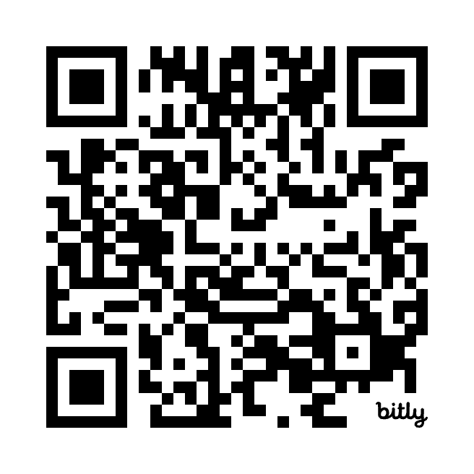

But 9/10 times, there’s no real reason. They’re just “busy.” So if that’s the case or they still say no to the test drive, we’ll use my favorite disarmingly blunt line to call it out in the next objection (and that line works perfectly here too).

3) Dismissive Objection: Send Me Some Information
Call me in 6 months and send me some information are very similar objections. No one actually wants to read your generic marketing materials, they’re just too nice to reject you. Instead, be disarmingly blunt and call it out:
Prospect: Thanks, send me some information and I’ll take a look.  You (Agree): Oh for sure. I’d wanna digest it all first too.  You (Incentivize): Just so I don’t clutter your inbox, was there a specific question you had in mind or just a general overview?  Prospect: Just a general overview.  You (Test Drive): Haha, I’m the king of “this meeting should’ve been an email” too. But I’ll be honest, those PDFs aren’t gonna be relevant at all… and you’ll know if this is a fit in the first 15 minutes. Opposed to taking a look, and if it’s not a fit I can give you 15 back?”  Prospect: No no, I’d really prefer some information.  You (Permission): Okay, waving my white flag! Before I go, mind if I ask you a brutally honest question?  Prospect: Sure.  You (Disarmingly Blunt) When folks tell me to send them some info, they’re just too nice to tell me to go away. Is that what’s happening?  Prospect: No of course not! I promise I’ll at least take a look.  You (The Dart): Okay, here’s our deal. I’ll send you the info, call out exactly what’s relevant to you, and send a placeholder invite for next week. If you don’t like it, you can just decline the invite. Fair? | Multiple-choice  (Not interested)  Disarmingly blunt  Give them control  Use permission for hard questions  Call them out in compliments  I put time into my follow-up, you agree to read it
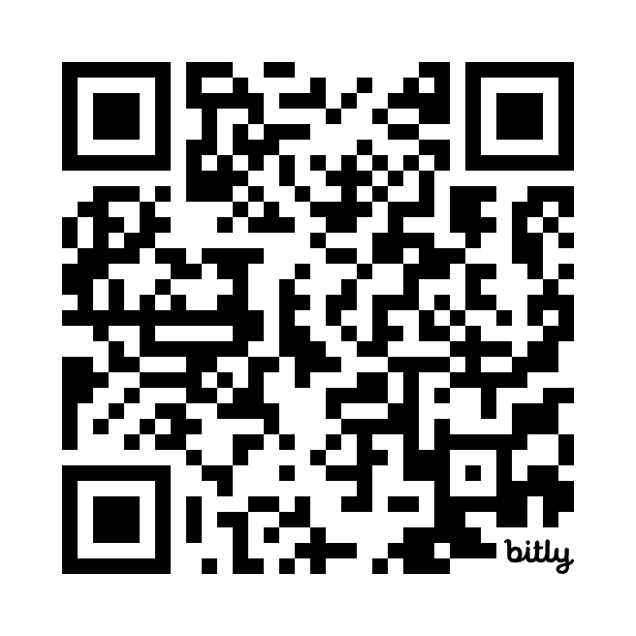

When you call out the lie, get them to stand by it, then put even more work into your follow-up to create goodwill… they’re far more likely to accept the placeholder meeting.

4) Dismissive Objection: Not My Responsibility
There are one of two possibilities. They’re either the right person (and they’re lying), or they’re actually the wrong person. Regardless, the approach is the same.
Drop the name and title of the person you think should be responsible for evaluating your product. If they were lying, they’ll fess up with the real objection because they don’t want you to cold call their colleague. From there, run Miyagi again on that objection.
If they’re not the right person, your goal is to get a referral instead of a test drive. I find that it’s very unlikely that they’ll make the referral because you’re a complete stranger. Instead, I ask for permission to mention their name when I reach out to their colleague:
Prospect: Yeah, that’s not my responsibility.  You (Agree): Ah, my bad. It’s funny, this kind of thing usually either lives with you as the Head of Content or with your Head of Demand Generation. Guess I was wrong here.  You (Incentivize): Just so I don’t bug the wrong person, is this in Jane’s court? (Their Head of Demand Generation)  Prospect: Yeah, Jane would be the one.  You (Permission): Could I ask you for an extremely unreasonable favor from a complete stranger?  Prospect: Sure.  You (Referral): I was gonna send her a note after this. Mind if I let her know we spoke? | Know the personas that buy your thing  I’m calling her next  Use permission for big asks.  Note: I was already gonna reach out
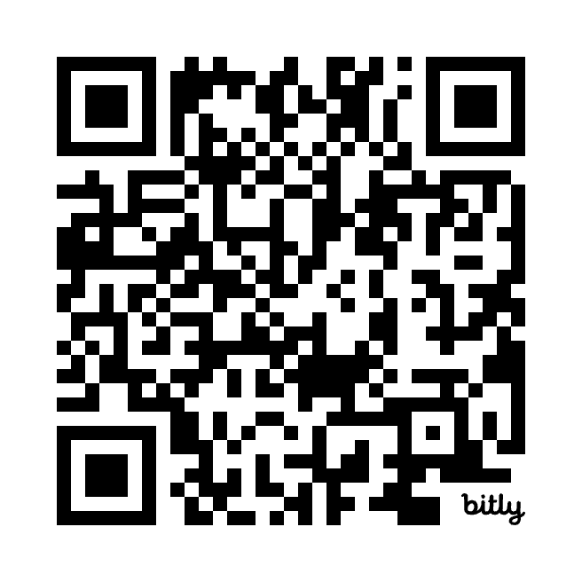

When you make it clear you were gonna reach out to the other prospect anyway, they’re more likely to agree to the name drop. From here, I’ll usually write a new email to the referral with the subject line: Spoke with Nick. You’ll get a reply.

5) Pre-Pitch Dismissive Objection: Where’d you get my number!?
Remember: Agree hard and be disarmingly blunt. Many reps will sweat, stammer, and hesitate to share how they found the number (as if contact databases were a hidden secret).
Instead, be disarmingly blunt by explicitly sharing the name of the tool and offering to screenshot their entry in the database. Your prospect is clearly surprised and pissed off. But you can pattern break by being even more transparent than they expected you to be:
Prospect (Pre-Pitch): Where’d you get my phone number!?  You (Agree): Oh shoot! It’s a contact database called Banana Leads.  It sounds like I really ruined your day here, so I’d be happy to send you a screenshot of what they have on file so you know what’s out there.  Prospect: Well… no that’s fine I don’t need that.  You (Incentivize): Look, I don’t love making these calls and I know you don’t love getting them. But I actually prepared for this one.  Just so no one calls you again, could I tell you why I called you specifically, then you can hang up on me from there? | Disarmingly blunt.  Disarmingly blunt  Disarmingly blunt  Permission
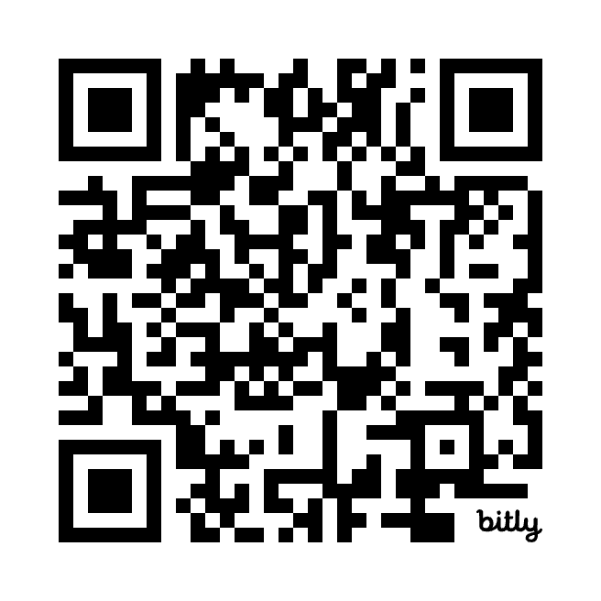

From here, they’ll usually ease off the gas because you’re double incentivizing them by not only offering to make this the last cold call they get from you, but perhaps the last cold call they get from anyone who has this contact list.

6) Pre-Pitch Dismissive Objection: I’m in a meeting!
This one frankly pisses me off. No one is answering their phone in a meeting and if they were, it clearly wasn’t important. It’s the most BS swat of them all, so I prefer to match the ridiculousness of the objection with a laughably unreasonable ask to put me on speakerphone.
From there, many sellers make the mistake of offering to call back at another time, at which point your prospect enters the witness protection program and never answers your call again.
Instead, give them two options: a calendar invite for later or a conversation now:
Prospect (Pre-Pitch): I’m literally in a meeting right now.  You (Agree): Oh shoot! Well if you want, you can put me on speaker to publicly apologize to the group and I can really bomb on this one.  Prospect: No, no… what’s this about?  You (Incentivize): But actually, I’d hate to interrupt you again.  Would you rather have me send a hold to call you back at the top of the hour, or briefly tell you why I called now so I don’t bug ya again? | Liar.  Disarmingly blunt  Meet later or get it over with?
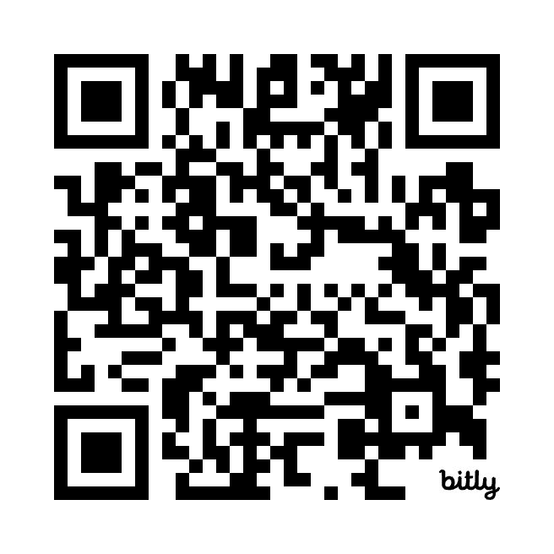
The calendar invite sounds really unattractive because now they’re agreeing to a second cold call and frankly they don’t want random invites from a stranger.
For everyone else who wants the call back, send the invite. Sure, maybe they’ll decline it. But a 50-50 shot at a calendar invite is better than calling back to find out they blocked your number.
Plus, you can attach a personalized video or a thoughtful note to the invitation to build some goodwill and increase the chances that it sticks.

7) Pre-Pitch Dismissive Objection: Is this a cold call!?
This is almost always an irate old man in shock that he’s being cold called. If you freak out, stammer, and sweat, you’re only justifying his tantrum and you’re gonna get bulldozed.
Be the opposite of irate and unreasonable so they feel ridiculous for reacting like a child.
Call out the fact that the call is going horribly and both of you aren’t enjoying this. Give them the right to slam the door in your face and they’ll realize they’re completely out of line:
Prospect (After Your Opener): Is this a cold call!?  You (Agree): Yes and it’s going so, so badly.  Look, I know you probably hate getting cold calls. I honestly don’t like making them either, but I took some time to research you personally because everyone hates telemarketers.  You (Incentivize): Just so no one from my team ruins your day again, could I tell you why I called and if nothing else you can hang up on me then if it’s really not a fit? | Disarmingly blunt  Disarmingly blunt  Permission
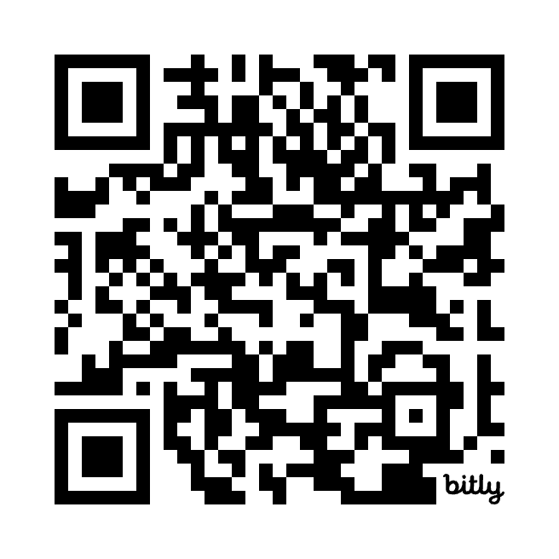

If you approached this prospect at a conference with some really thoughtful things you knew about them, there’s no way they’d chew you out on the public floor. Recreate the face-to-face interaction through your words and they’ll feel like a total jerk for piling on more.
The only reason they’re doing this is because it’s a cold call.

8) Pre-Pitch Dismissive Objection: I thought you were someone else
Okay, imagine this. You’re waiting for your good friend Nick to show up at your house. The snacks are ready. The music is bumping. You’re having a jolly old time.
Ding-dong! You rush to the door, champagne glass in hand.
“Ayyyyy! Come on i-i–...” Oh… the solar panel guy.
“Wanna save on your Prius charging bill?”
When it gets awkward, lean into it. If you act awkward, you’re just a lingering annoyance. But crack a good joke and you’ll usually get a shot on goal, like this:
Prospect (After Your Opener): I thought you were someone else.  You (Agree): Well I can change my tone of voice and pretend to be someone different if you’d like!  But actually, I hate it when I’m waiting for a call, then I pickup and someone’s trying to sell me SiriusXM radio.  You (Incentivize): I’d hate to do this to you twice.  Could I just tell you why I called you, and I promise, if that person calls you back, you can hang up on the spot? | Disarmingly blunt  Give them the out
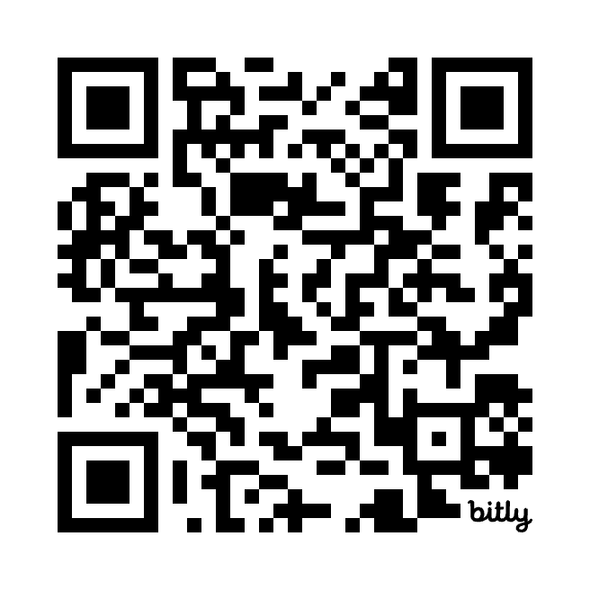

It’s critical when you pivot back to your permission-based opener, you let them know that they can hang up if that person calls back. Otherwise, they won’t give you permission because they’re worried about missing the call back.
Notice the pattern with these last few. Make a joke that almost seems more extreme than the objection itself. Ask for permission using an incentive (just so we don’t interrupt you again).
And just as we were getting that pattern down, this last one is a change-up. Silence.

9) Pre-Pitch Dismissive Objection: *Hang Up*
Many people say you should immediately call back a prospect who just hung up and say something like “I think we got disconnected.”
The success rate with this approach is basically zero. You both know they hung up and you’re only going to frustrate them more by calling back immediately and acting dumb.
Instead, make a note of these 3 things when someone hangs up: The call date, the call time, the exact words they said before hanging up. Move onto your next dial for now.
Call back a week later and use those 3 things as context in your tailored permission opener:
Prospect (Pre-Pitch): I can’t talk now, I’m crazy busy preparing for a big meeting. *click*  **One Week Later**  You (Context): Emma, you and I last spoke on October 19th around 2:30 in the afternoon. At the time, you couldn’t talk because you were crazy busy preparing for a big meeting, and you admittedly hung up on me.  You (Own The Cold Call): I know I was an interruption, and I guess I’m interrupting you now… but I promise I prepped for this one and I’m calling you for a reason.  You (Permission): Could I at least tell you why I called you back, then you can totally hang up on me from there? | Date & Time  Guilt  Guilt x2  Guilt x3
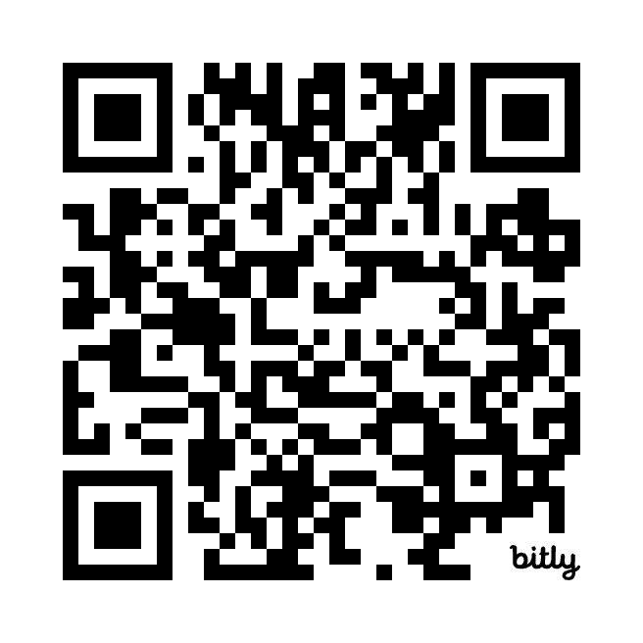

When you cite the exact date, time and words the prospect said… and restate what you know about them, you get their attention. You recreate the moment where they hung up on an actual human being who was really trying to have a thoughtful conversation. They’ll feel like a jerk.
This also shows that you’re professionally persistent. Not because they’re dial number 472, but because there’s something we saw about them that made us call again.
If they hang up again, try the same approach on a different channel (IE: Email, LinkedIn).

Situational Objections
Buying products means an investment of time, money, and people. Even if they see the benefits, they imagine all the work they’ll have to do to realize them: begging for budget, assigning someone to manage the project, burning political capital if it doesn’t work.
The cost of the transition outweighs the benefits of the product. So you have to remove all pressure of buying the car until you get them so excited that they realize it’s worth it.
You do that with the test drive. Once they’re in the car, we can blow their mind with the drive, explain how easy it is to finance the car, and let them drive it off the lot today.
But not on a cold call. Get them in the car.

10) Situational Objection: No Budget
Prospects rarely have spare dollars waiting to be spent. But this is a common situational objection because asking for money is painful. They have to risk political capital, put together ROI cases, and even replace existing tools. Acknowledge this when you agree.
Another factor is that budgets work in cycles. Use multiple-choice to find out if it’s a timing issue (ie: new budget will be released) or a value issue (you’ll have to fight to create budget).
Regardless of their response, remove the pressure of the purchase entirely. Instead, give them a way to win more funds for their team, which is a test drive that everyone wants:
Prospect: Sorry, we don’t have any budget.  You (Agree): I hear ya. Nowadays, it’s hard enough to keep your budget, let alone add something new.  You (Incentivize) Just so no one calls you again, is it that there’s no budget for this cycle or that any spend requires you to do a triple backflip?  Prospect: It’s a bit of both, to be frank. We’re really tight right now.  You (Test Drive): I get it. Hey, you’re probably not gonna buy this thing now.  But if budget ever frees up, the people that get it at least have a directional sense of what’s on their wishlist.  Open to taking a look, so you at least know what’s out there? | Tells us if it’s a timing or value issue  Mini push-away  Don’t lose your shot to buy something
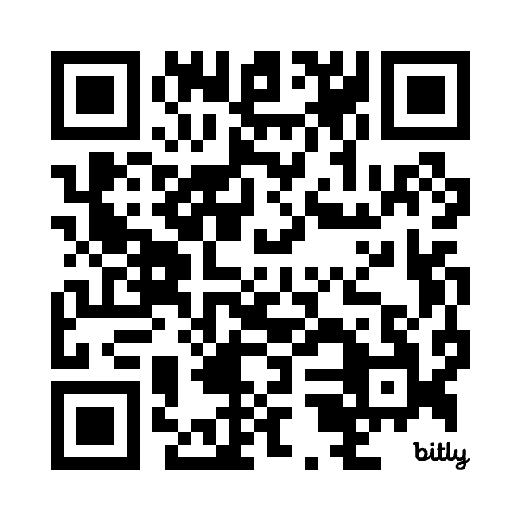

This is a good example of a mini push-away statement in action. Use them a lot with situational objections. Unlike dismissive objections, they’re not fighting the interruption as much as they’re fighting the thought of buying something.

11) Situational Objection: Too Expensive
This one is really similar to no budget, except it’s externally aimed at your product instead of internally aimed at their approval process.
One of two things is true: either the past rep couldn’t sell the value or this prospect really is freaking cheap and got sticker shock. So use multiple-choice to figure that out.
Regardless, you’re not going to convince them that it’s worth the price on the call. So explain that there’s flexibility on price without locking yourself into a discount. That’s your test drive:
Prospect: Your product’s way too expensive.  You (Agree): Oh, that’s interesting. Look we’re never the cheapest, but we’re also never astronomically high.  You (Incentivize): If you don’t mind me asking, just so no one calls again, was it the sheer dollar amount or the fact that you didn’t see enough value for the price?  Prospect: It looked cool, but we’re paying around $12k per year now and couldn’t justify paying $20k with you.  You (Test Drive): Look, not crazy far off. But we can skinny this down or beef it up depending on what you need.  You might’ve heard a price that included more than you needed or maybe it wasn’t clear what the extra $8k was gonna get you.  I’m not promising it’s gonna be way cheaper, but could I at least walk you through a few options so you know what’s out there? | Sticker shock or value issue?  There’s interest.  Allude to flexibility  While also alluding to a value issue
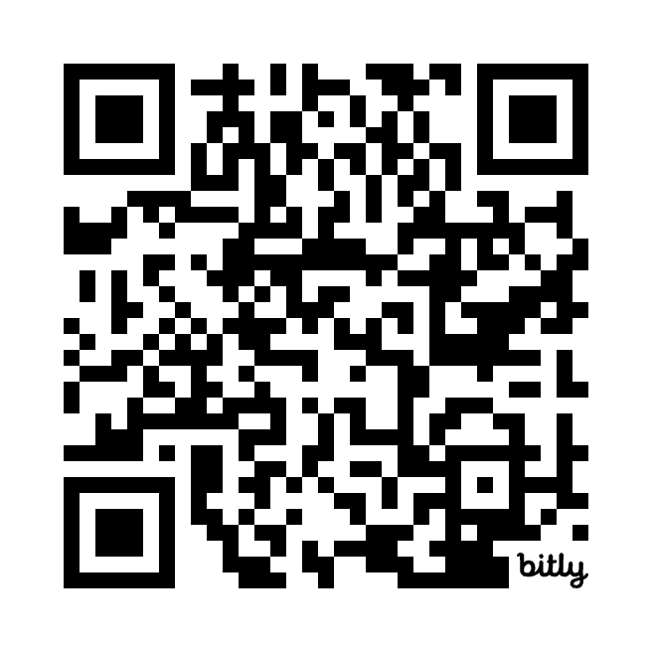

Once you’re on a live call, you can show them that the $8k price increase produces double that in value, or realize that they’re super cheap and give them a bare bones proposal to win the deal. But again, we shouldn’t lock into either of those options on the cold call.

12) Situational Objection: No Resources / Bandwidth
This is similar to call me in 6 months. People love to posture about how busy they are, but that never changes. To this day, I’ve never heard someone say that they have a whole bunch of bandwidth laying around.
Ask if this is a now or forever bandwidth issue (with some exaggeration humor below). Frankly, it doesn’t matter. The only reason you ask is to demonstrate that you’re listening and getting them talking.
Then use the objection to sell the test drive where you can show them how other teams do more with less. Here’s how that sounds:
Prospect: We’re stretched thin and can’t really can’t take this on.  You (Agree): I hear you. Literally every marketer we talk to today has 3 jobs.  You (Incentivize): I’d hate to bug you again when you’re already swamped. Mind me asking, is this just a temporary phase or does it look like you’re gonna be swamped until 2032?  Prospect: Haha, feels like 2030 at this point.  You (Test Drive): I figured. Well, I’ll pencil the contract start date for January 1st, 2032 for now. Look, I know you’re swamped. But our best customers are lean teams who need some extra firepower behind em.  You’re probably still not gonna buy this. But could I at least show you how we help other folks, just so you know what’s out there? | Disarmingly blunt  Disarmingly blunt. Have fun!  Mini push-away
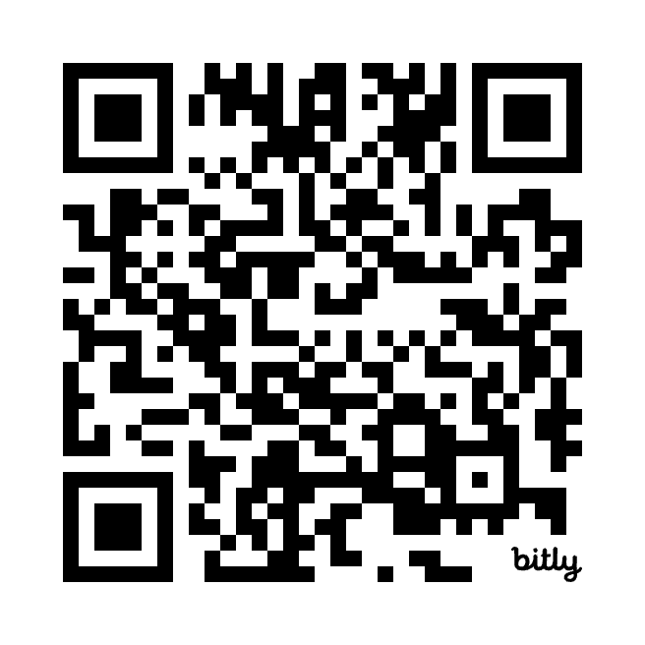

You’re probably seeing the pattern for situational objections by now.
Let them think they’ve won with the objection today, convince them in the car. Later on, we’ll show them time they’ll save with our product, but not on a cold call.

13) Situational Objection: Need to hire someone first
We get this a lot when we’re selling 30 Minutes to President’s Club sponsorships. We know that we’ve sold dozens of deals without a CMO in-seat because a marketing team needs to generate pipeline 365 days per year. But they feel like the entire world is frozen.
The problem is that recruiting searches take months. So incentivize them to share if they’ve already made the hire or if the search is ongoing.
If the person starts next month, great. Send a placeholder invite for then.
If not, you can’t wait. Sell them on taking a look today so they have a punch list of strategies they can present to the new boss:
Prospect: We can’t take this on until we hire our new CMO.  You (Agree): I hear you. No one wants to make a big decision that gets unwound when the new boss arrives.  You (Incentivize): I’d hate to bug you before they’re onboard, is the search just getting started or does the new CMO have a start date?  Prospect: The search just started, so probably 1-2 quarters.  You (Test Drive): Yeah, you’re probably not gonna buy this now.  But oftentimes the new CMO comes in with big ideas and she’ll wanna know what’s at her disposal.  So would you be opposed to taking a look, so you have a list of things in your toolkit that you can share with the new head honcho? | The world is frozen.  Starting next month or waiting forever?  Pushaway  Aka: look good for the new boss
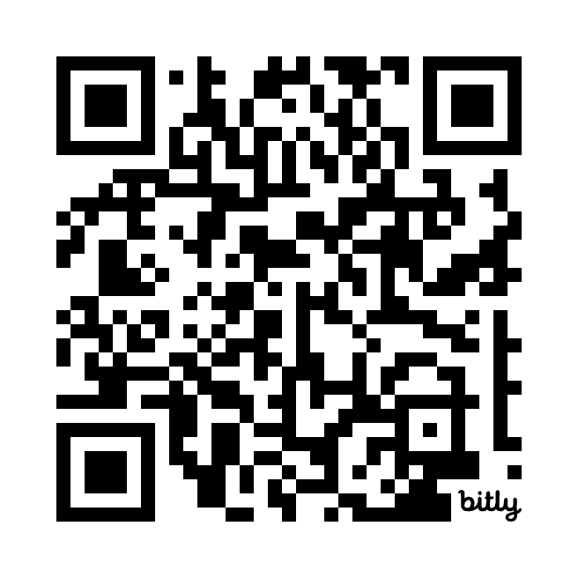

There’s another iteration of this one where they’re not waiting for a head honcho-type like a CMO, but they’re waiting for a specialized resource to own the problem like a Head of Content. The logic still applies. Make it easy for that person to get started when they join.

14) Situational Objection: It’s not made for XYZ
This one came up all the time when I was selling at an early stage FinTech startup. Once we started winning the small-medium business (SMB) market, we tried to crack into enterprise accounts. But then we had to fight our own reputation of being made for the little guys.
You really need to use multiple-choice here to figure out why they think they’re not a fit.
From there, rely on social proof to sell the test drive. It’s almost impossible for you to be the person that rewrites your reputation. But if you make it seem like you’re willing to put them in touch with other customers, it shows you might actually have something worth looking at:
Prospect: It’s really not made for enterprise companies.  You (Agree): Hmm, you know that’s surprising to hear. But I can totally respect that you wouldn’t even look at a tool if you weren’t 100% sure it’d scale into the thousands of employees.  You (Incentivize): Look, I’d hate to have someone reach out again if we’re really not a fit here. Was it something with our product, support, or something else?  Prospect: I mostly heard it in my CFO networking group that you don’t scale well with public companies.  You (Sell The Test Drive): Hmm. Look, I can tell you know your stuff and I know I’m not gonna convince you on a cold call.  But we’ve had several companies go public with us and I’d eventually be happy to make the introduction if it made sense.  But first, could I show you how we’ve helped other public companies, so you can see it with your own two eyes for yourself? | Agree with the concern, not the reputation  Why aren’t we enterprise ready?  Ego booster  Lean into social proof hard
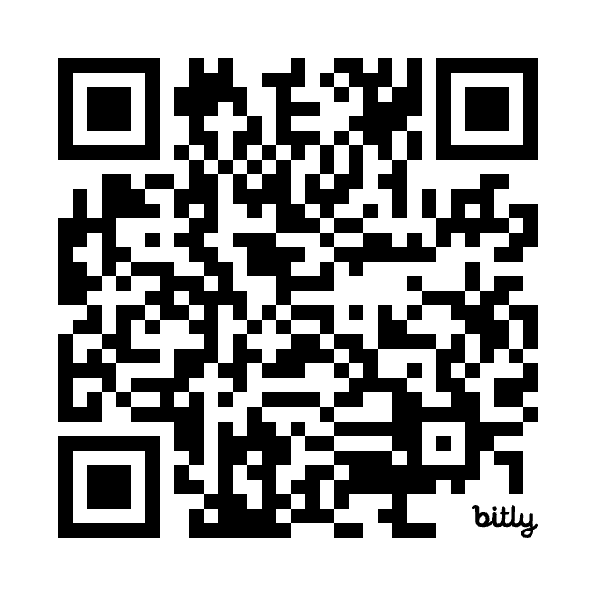

This approach works for any product objection. Offer to show them why a respected peer chose you. Then make the introduction to the customer reference later if it seems like a fit.

Existing Solution Objections
Reps make the mistake of criticizing and throwing mud at a prospect’s current solution, which only makes them defensive and far more likely to push you away.
That said, even if they’re happy with their solution, no solution is perfect. If you can get them to realize a problem on their terms instead of your terms, they might be open to a solution.
Here’s how that plays out in the Miyagi Method:
- Agree with their current solution so that they don’t get defensive.
- Incentivize conversation with a trap question to poke a hole in their solution.
- Sell the test drive with social proof, or why other people like them switched.
The tone is really important when revealing flaws in someone’s solution. Lean into the pushaway. Remember: Noah started with “Curious, you’re healthy” before asking the trap question. If you sound like you’re asking a “gotcha” question, they’re gonna get defensive.

15) Existing Solution: We do it in house
This is an actual example from when I sold equity management software to startups. In the early days, a CFO would often manage their equity out of spreadsheets – it was an annoyance, but not so annoying that they couldn’t deal with it.
But in the later stages of a company, they need to perform two accounting exercises to stay compliant: 409A Valuations and ASC 820 Expense Accounting. These are both very costly and often require you to work with a 3rd party. Fortunately, we provided both of these services.
From there, you’d simply ask a trap question to show them what was possible:
Prospect: We’re good, I manage our equity myself.  You (Agree): Oh wow! Usually when that happens, it means you’ve still got those spreadsheet wizard skills.  You (Incentivize): Honestly, sounds like it’s really not a pain. Just so no one else calls, out of curiosity, you must not be doing 409A valuations or ASC 820 Expense Accounting yet right?  Prospect: Well, we do. But we work with Acme for that.  You (Test Drive): Oh… well the reason I ask is because most CFOs are surprised when they find out they can get those things for free because they’re included for all of our software customers.  You’ll probably keep managing this yourself, but if nothing else, could I give you a sense of what it’d look like to consolidate the spend? | More ego stroking  Trap question  Amplify the problem with social proof  Pushaway
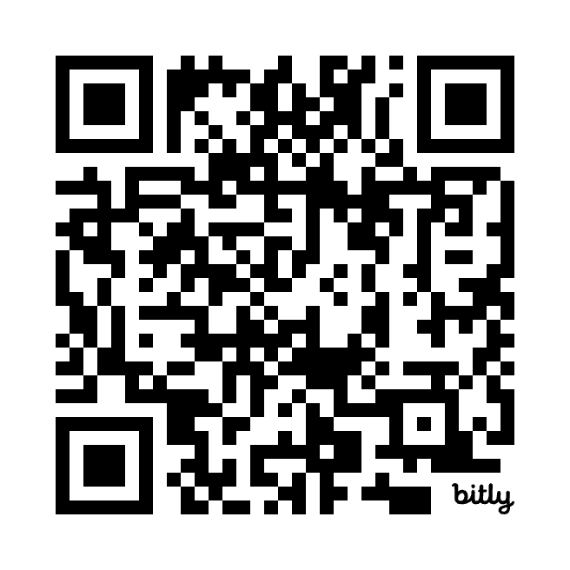

16) Existing Solution: Competitor (Known)
Let’s take another example. I sold compensation software as the VP of Sales for a company called Pave. We were 2-3x the price of our competitors because we could manage stock option bonuses that were too complex for our legacy competitors to handle.
That made for a perfect trap question:
Prospect: We’re using CompEx.  You (Agree): Oh CompEx! They’re a great group. Honestly, it rarely makes sense to switch if you like them.  You (Incentivize): Hey, just so we don’t bug ya again. That must mean you’re not doing stock option bonuses, right?  Prospect: Well, we are… why?  You (Test Drive): Oh… well other HR teams often found that managers would request bigger cash bonuses because most platforms don’t let you see the value of both the cash and stock in one place. And we help with that.  My guess is you won’t switch, but could I give you a sense of how you might manage those things together, just so you know what’s out there? | Never badmouth.  Trap question  Amplify the problem with social proof  Pushaway
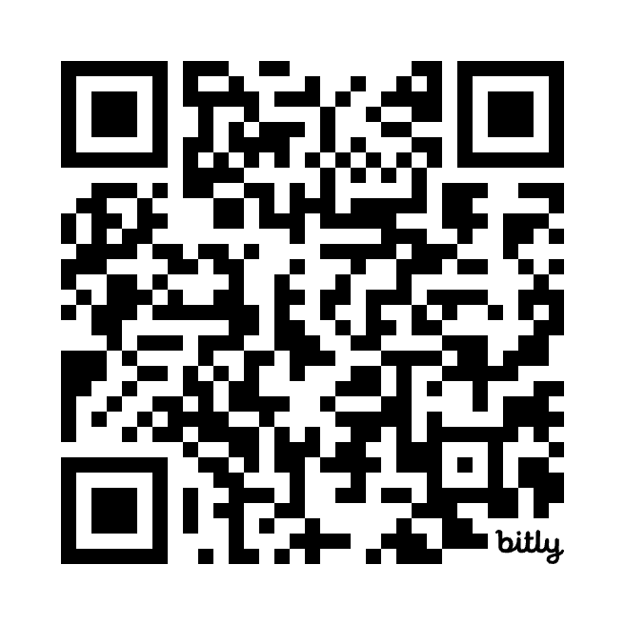

Again, never badmouth a competitor. When you explain that a similar customer faced a similar problem and made the choice to switch, their actions speak louder than your sales words.
But what’s tricky is sometimes you can’t reveal the problem… because you don’t actually know the competitor. So you have to reveal them first. That’s next.

17) Existing Solution: Competitor (Unknown)
You really need the name of the competitor to reveal a problem. But again, you can’t just ask “who are you working with?” because prospects don’t want to share their business decisions with a complete stranger.
So instead, incentivize them to share the competitor, then run Miyagi again to reveal the problem. Use multiple choice when asking about the competitor because people tend to clam up when you ask “who are you working with” for whatever reason:
Prospect: We’re already working with another vendor.  You (Agree): Oh, I should’ve assumed you had something in place.  You (Incentivize): Just so I mark this one as dead, must be CompEx, Compensatory, or Comptastic, right?  Prospect: Yeah, it’s CompEx  **Got the competitor, run miyagi again**  You (Agree): Yeah, honestly it rarely makes sense to switch.  You (Incentivize): Hey, just so we don’t bug ya again. That must mean you’re not doing stock option bonuses, right?  Prospect: Well, we are… why?  You (Test Drive): Oh… well other HR teams often found that managers would request bigger cash bonuses because most platforms don’t let you see the value of both the cash and stock in one place. And we help with that.  My guess is you won’t switch, but could I give you a sense of how you might manage those things together, just so you know what’s out there? | Multiple-choice  Got the competitor!  Trap question  Amplify the problem with social proof  Pushaway
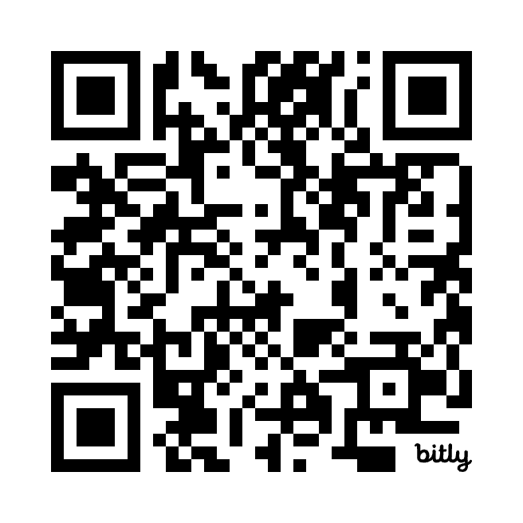

As noted above, you’ll notice we incentivize them to share more information twice. Try to use a different incentive for each, otherwise it comes off as canned.

18) Existing Solution: Stuck in a contract
This last one seems tricky because there’s both an unknown competitor and a timing issue, but it’s actually exactly the same. There’s only one change: remove the pressure of the sale today when you sell the test drive.
In other words, prioritize handling the competitor issue first. Then get them to take a test drive by removing the pressure of the rip-and-replace today:
Prospect: We’re already under a 12 month contract.  You (Agree): Oh, I should’ve assumed you had something in place.  You (Incentivize): Just so I mark this one as dead, must be CompEx, Compensatory, or Comptastic, right?  Prospect: Yeah, it’s CompEx  **Got the competitor, run miyagi again**  You (Agree): Yeah, honestly it rarely makes sense to switch.  You (Incentivize): Hey, just so we don’t bug ya again. That must mean you’re not doing stock option bonuses, right?  Prospect: Well, we are… why?  You (Test Drive): Oh… well other HR teams often found that managers would request bigger cash bonuses when they can’t see the value of both the cash and stock in one place. And we help with that.  My guess is you won’t switch until your contract is up, but could I give you a sense of how you might manage those things together, just so you know what’s out there? | Multiple-choice  Got the competitor!  Trap question  Amplify the problem with social proof  Only Change: Pushaway the rip-and-replace
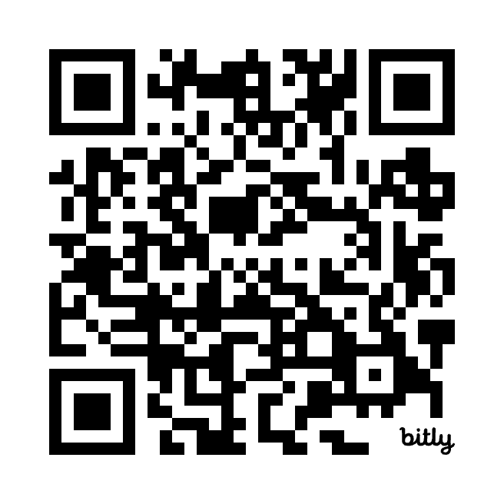

Once we’re on the call, we can talk about all of our differentiators, contract buyouts, and more. But not now, they don’t even want to think about a rip and replace. Get them in the car.

Whenever you're ready, this is our top 1% advice:
We give away 99% of our content for free. The 1% below is our best stuff, broken down step-by-step so we spoon feed you the tactics that get you to President's Club.
1. Book: Cold Calling Sucks (And That's Why It Works): Join 35,000+ readers of the #1 cold calling book with step-by-step talk tracks, real voiceovers embedded in QR codes, and Gong data behind every tactic.
2. Cold Calling Course: Cold Calls to President's Club: The secret to booking 1 in 4 cold calls is mastering the delivery. Take the book a step further with new frameworks, examples, and real call reviews so you know exactly what to say and how to say it.
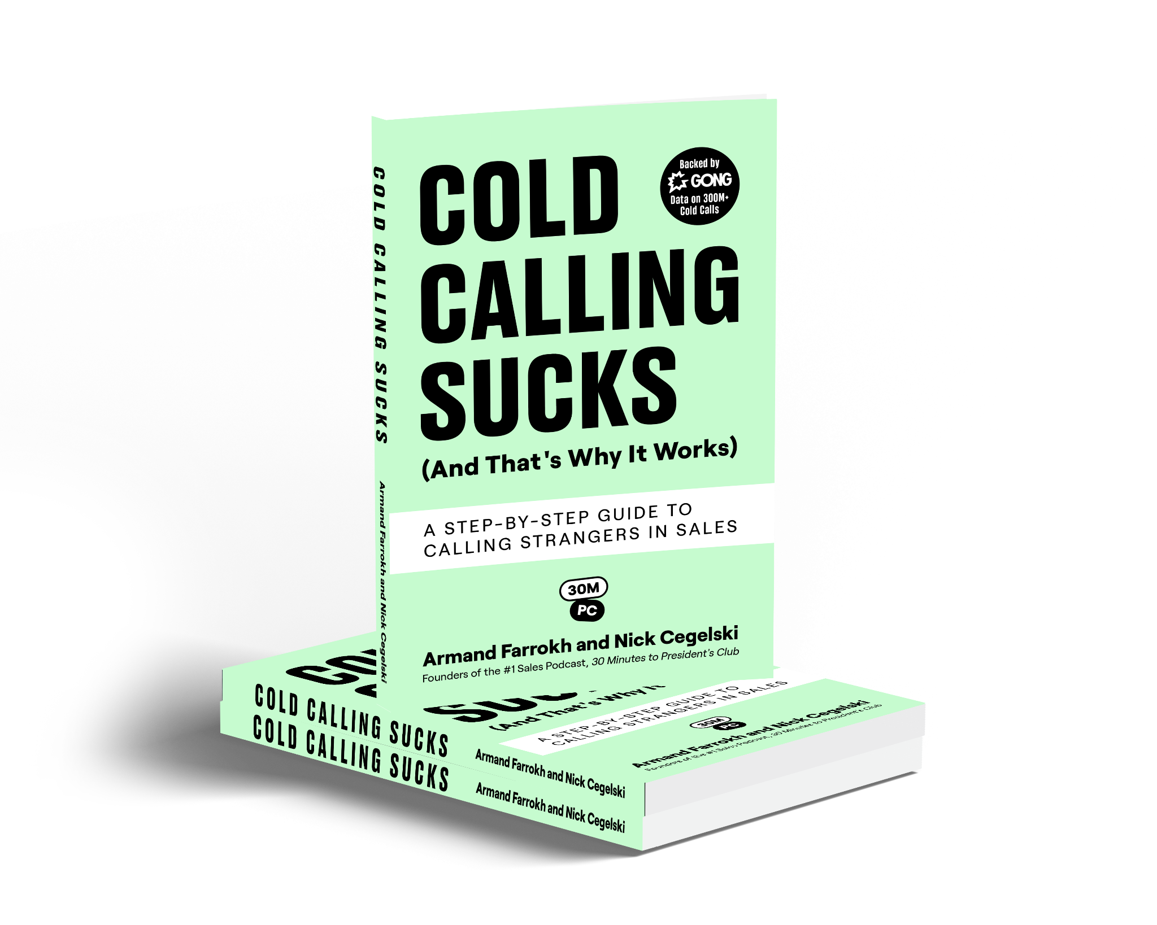

Our Top 1% Advice

Whenever you're ready, this is our top 1% advice:
We give away 99% of our content for free. The 1% below is our best stuff, broken down step-by-step so we spoon feed you the tactics that get you to President's Club.
1. Book: Cold Calling Sucks (And That's Why It Works): Join 35,000+ readers of the #1 cold calling book with step-by-step talk tracks, real voiceovers embedded in QR codes, and Gong data behind every tactic.
2. Cold Calling Course: Cold Calls to President's Club: The secret to booking 1 in 4 cold calls is mastering the delivery. Take the book a step further with new frameworks, examples, and real call reviews so you know exactly what to say and how to say it.


